- Introduction

The Indian legal system oversees a vast volume of cases annually, with judicial verdicts frequently extending across hundreds of pages of dense documentation. This sheer volume makes the manual analysis of historical precedents and the forecasting of future case outcomes an exceptionally complex, labor-intensive, and time-consuming process for legal practitioners. Consequently, there is an urgent industry requirement for advanced computational tools to assist in navigating this complexity.
This project presents a production-ready Artificial Intelligence (AI) framework specifically engineered to predict the outcomes of Indian Supreme Court cases while proactively addressing modern transitions in the legal landscape. Predicting the resolution of a court case is a critical task within legal analytics, serving to foresee judicial decisions by synthesizing written laws and historical precedents. Predictive methodologies in this field are generally classified into three distinct types: the socio-political approach, which examines extrajudicial factors like a judge’s background or ideological inclinations; the linguistic approach, which identifies patterns in document structure, sentiment, and vocabulary; and the legal-centric approach, which focuses on the specific facts of each case alongside relevant statutory laws.
A significant computational hurdle identified in current Indian legal tech is the "temporal shift"—the evolution of legal interpretations and societal norms over time, which often renders older models obsolete. Furthermore, the recent legislative transition from the Indian Penal Code (IPC) to the Bharatiya Nyaya Sanhita (BNS) has created a unique computational challenge, as legacy AI models were trained exclusively on outdated legal terminology. Our system addresses this by introducing a dynamic middleware layer that automatically translates historical laws into updated forms before inference, ensuring that the model maintains high relevance to current legal standards.
Finally, to bridge the divide between academic research and commercial viability, the entire workflow is integrated into a secure, full-stack architecture. This framework utilizes Supabase for robust lawyer authentication and cloud-based case storage, demonstrating the model's readiness for practical, real-world deployment in the Indian judicial ecosystem.

1.1 History
The field of legal predictive analytics has evolved significantly, transitioning from primitive manual assessment methods to advanced computational frameworks. Historically, predictive modeling in the legal domain has been categorized into three distinct methodologies: the socio-political approach, which emphasizes extrajudicial factors such as a judge's personal background and ideological inclinations ; the linguistic approach, which identifies trends in document structure, sentiment, and word frequency within legal texts ; and the legal-centric approach, which concentrates specifically on case facts and the application of related statutory laws.
Over the last decade, computational legal technology has advanced from traditional classification algorithms—such as Support Vector Machines (SVM) and Random Forest models—toward sophisticated, domain-specific Natural Language Processing (NLP) architectures. Early benchmarks, such as those established by Katz et al. (2017), focused on modeling judicial behavior over long horizons, while more recent advancements have leveraged Transformer-based models like BERT to handle the semantic density of legal language. The field has progressively shifted toward addressing the complexities of "temporal shifts," where legal interpretations evolve alongside societal norms, necessitating models that can adapt to changing statutory structures. The current trajectory of legal history in technology is defined by the integration of Explainable Artificial Intelligence (XAI), moving away from "black-box" systems toward transparent frameworks that provide justifiable reasoning pathways, ensuring that automated predictions meet the rigorous accountability standards of the Indian judicial ecosystem.
1.2 Literature Review
The literature review on Indian legal technology highlights an increasing requirement for multilingual understanding and interpretable reasoning to bridge the gap between complex statutory frameworks and practical law enforcement systems. Recent improvements have focused on domain-specific benchmarks, such as IL-TUR, which have expanded research across many Indian languages and allowed for task-specific evaluation of legal NLP systems. However, significant challenges persist in cross-lingual reasoning and in optimizing the baseline performance of Large Language Models (LLMs) when utilized for Indian legal texts, which are highly complex in both structure and meaning.
Existing literature notes a shortage of large-scale annotated corpora and a lack of representation for regional languages. A primary technical hurdle is that Indian legal documents frequently exceed 4,000 words, far surpassing the 512-token limitation of traditional transformer architectures such as BERT. This limitation necessitates the development of advanced chunking and large-document modeling strategies. Furthermore, the high semantic density of statutory interpretation makes it difficult for black-box neural models to create transparent outputs that satisfy judicial accountability standards.
To address these boundaries, current research has pivoted toward Explainable Artificial Intelligence (XAI) frameworks. While XAI-based models may display slightly condensed predictive precision compared to fully optimized black-box systems, they significantly enhance user trust by providing justifiable reasoning pathways. The urgency for such systems has intensified with India's legislative change from the Indian Penal Code (IPC) to the Bharatiya Nyaya Sanhita (BNS), creating a critical need for adaptable computational frameworks capable of handling growing statutory structures. Current benchmarks in the field are illustrated in the comparative analysis below:
Sr. No. | Author | Dataset | Method | Contribution
1 | Katz et al., 2017 [21] | US Supreme Court | Random Forest | Long-horizon behaviour modelling
2 | Malik et al., 2021 [23] | ILDC Corpus | Hierarchical model | Indian legal prediction benchmark
3 | Liu et al., 2024 [24] | CAIL2018 | LegalDuet | Dual-view reasoning
4 | Nigam et al., 2024 [27] | NyayaAnumana | Legal LLM | Large-scale Indian legal baseline
5 | Garzo et al., 2025 [8] | Criminal data | Transformer | Interpretable judicial prediction
6 | LIPE Model, 2025 [18] | US Supreme Court | Ensemble + NLP | Hybrid feature engineering

1.3 Gap Findings
A. Architectural & Computational Gaps
- Limited Context Understanding: Traditional machine learning models (such as SVM or Naive Bayes) fail to capture the nuanced legal reasoning and context required to interpret complex judgments.
- Handling Long Documents: Most standard Transformer-based models operate under a 512-token limit, leading to the loss of critical information when processing lengthy legal case documents.
- Poor Handling of Legal Structure: Existing systems often fail to properly separate specific document sections like "Facts," "Arguments," and "Judgment," which results in inaccurate predictive modeling.
- Data Limitations: Research is frequently constrained by a shortage of large, well-annotated datasets, further exacerbated by the presence of messy, unstructured legal text.
B. Legal Transparency & Adaptability Gaps
- Lack of Explainability (Black Box Problem): Many high-accuracy AI models function as "black boxes," providing predictions without transparent justifications, which reduces trust among legal practitioners and fails to meet judicial accountability standards.
- Static Models: Existing systems lack adaptability to evolving laws, such as the transition from the Indian Penal Code (IPC) to the Bharatiya Nyaya Sanhita (BNS), leaving them unable to provide relevant or current guidance.
C. Practical Deployment & Linguistic Gaps
- Multilingual Challenges: While Indian legal data is inherently multilingual, the majority of existing models are trained primarily on English, creating a barrier to broader applicability.
- No Real-World Deployment Focus: A significant portion of current research remains purely theoretical, failing to provide the secure, user-friendly SaaS applications required for day-to-day legal workflows.
These findings confirm that while progress has been made in predictive modeling, there is a lack of end-to-end, explainable, and adaptable systems. The Legal AI bridges these gaps by implementing structure-aware chunking, dynamic IPC-to-BNS translation, and SHAP-based explainability within a secure, SaaS-enabled architecture.
1.4 Problem Formulation
The Legal Case Outcome Prediction project aims to develop a robust machine learning system capable of predicting the outcomes of court cases by analyzing historical legal verdicts. In common law systems like India, Supreme Court and High Court judgments serve as the backbone of legal understanding. However, the current manual process of reviewing large volumes of unstructured legal documents to identify relevant precedents and reasoning patterns is inherently time-consuming, subjective, and complex.
The fundamental problem lies in the disconnect between the massive influx of legal data and the lack of automated, explainable tools to process it. Specifically, our formulation focuses on three key technical and structural challenges:
- Extraction of Structured Evidence: Converting unstructured, verbose legal texts into actionable data points while maintaining the integrity of the original arguments.
- Adaptability to Legislative Evolution: Ensuring that the model remains functional amidst significant statutory transitions—specifically, the shift from the Indian Penal Code (IPC) to the Bharatiya Nyaya Sanhita (BNS)—which renders legacy models trained on outdated terminology ineffective.
- Balancing Accuracy and Transparency: Addressing the requirement for models to provide not just a binary outcome (e.g., "Dismissed" or "Allowed") but also interpretable justifications, as judicial accountability requires transparency in AI-assisted decision-making.
By training machine learning models on high-quality, historical case data, the system aims to automate the prediction of outcomes, such as whether an appeal will be allowed or dismissed. The core objective is to reduce the burden of manual legal research, enhance consistency in judicial analysis, and provide data-driven insights through a secure, scalable SaaS platform. This formulation transforms the manual task of judgment review into a streamlined, automated pipeline, assisting legal professionals and researchers in navigating Indian jurisprudence more capably.

1.5 Problem Solution
To address the inherent complexities of the Indian judicial system and the limitations of existing predictive models, we have developed an end-to-end, explainable AI framework designed for real-world legal decision support. The solution is formulated around a modular, full-stack architecture that transforms unstructured legal texts into structured, actionable intelligence.
Our solution is built upon four foundational pillars:
- Advanced NLP & Structural Chunking: To overcome the 512-token limit of standard Transformer architectures, we implemented a structure-aware chunking pipeline. This logic utilizes targeted Regular Expressions to strictly isolate the "Facts" and "Arguments" sections of legal judgments, ensuring that the inference engine processes the most legally dense and unbiased information.
- Dynamic Statutory Translation (IPC-to-BNS Middleware): To ensure the model remains relevant amidst legislative transitions, we integrated a vibrant JSON-based transformation layer. This middleware dynamically maps legacy Indian Penal Code (IPC) references to updated Bharatiya Nyaya Sanhita (BNS) provisions, allowing the model to evaluate historical cases using contemporary legal standards.
- Explainable AI (XAI) Integration: To solve the "black-box" problem, we integrated SHAP (SHapley Additive exPlanations) coupled with a spaCy Named Entity Recognition (NER) filter. This ensures that the system does not just provide a binary verdict, but highlights specific legal entities, laws, and case-specific decision drivers, providing practitioners with a transparent and verifiable decision path.
- Secure SaaS Implementation: The entire engine is wrapped in a production-ready, secure SaaS platform. By utilizing a Streamlit frontend and a Supabase (PostgreSQL) backend, we provide lawyers with robust, encrypted user authentication, a persistent cloud vault for case history, and an intuitive dashboard that enhances judicial consistency and saves research time.
Through synergising domain-specific transformer models—specifically fine-tuned InLegalBERT—with robust backend infrastructure, this solution effectively mitigates the risks of manual research and data loss. The platform provides data-driven insights that are grounded in actual case facts, empowering legal professionals and researchers to navigate Indian jurisprudence with greater speed, accuracy, and interpretability. This integrated approach ensures that the Legal AI Hub is not merely a research prototype, but a scalable, commercial-grade tool ready for integration into the Indian legal ecosystem.
1.6 Objectives
- Data Acquisition and Management: To systematically collect historical case judgments from the Supreme Court of India and interconnected legal repositories to create a reliable training corpus.
- Intelligent Data Preprocessing: To clean and structure unstructured legal texts by dynamically extracting essential components such as "Facts" and "Arguments," while implementing rigorous filtering to prevent data leakage from final judgment sections.
- Statutory Evolution Mapping: To implement a dynamic JSON-based transformation middleware capable of mapping legacy Indian Penal Code (IPC) references to the contemporary Bharatiya Nyaya Sanhita (BNS) framework, ensuring the model remains legally relevant.
- Semantic Entity Recognition: To apply advanced Natural Language Processing (NLP) techniques, augmented by spaCy Named Entity Recognition (NER), to isolate critical legal keywords and eliminate grammatical noise.
- Predictive Model Development: To fine-tune and deploy transformer-based architecture (InLegalBERT) to perform high-precision classification of case outcomes.
- Secure Cloud Infrastructure: To implement a robust, scalable cloud backend utilizing Supabase for encrypted user authentication, secure role-based access, and persistent historical case tracking.
- Explainable User Interface: To develop a professional-grade, interactive web interface using Streamlit that empowers legal professionals to analyze cases rapidly, supplemented by explainable visual decision drivers generated via SHAP (SHapley Additive exPlanations).

- System Architecture and Methodology
The proposed system utilizes a modular, full-stack architecture to ensure scalability, security, and high-performance predictive analysis. As illustrated in the architecture diagram, the workflow is designed as a continuous pipeline that bridges the gap between raw legal documents and interpretable judicial forecasts.
Key Components of the Architecture:
- Legal Professional (User): The primary interface actor who interacts with the system through a secure, state-based web portal.
- Streamlit Frontend (State-Based UI): Acts as the interactive entry point, managing user sessions and routing requests across various modules (Prediction, Vault, History) while ensuring a responsive user experience.
- Supabase Backend (Auth & PostgreSQL): Serves as the robust cloud foundation, providing encrypted user authentication, row-level security, and a persistent vault for historical case data and user logs.
- Data Preprocessing Engine: A dedicated module comprising three critical sub-stages:
  - PyMuPDF (Text Extraction): Extracts structured text from unstructured PDF legal documents.
  - JSON Middleware (IPC to BNS Translation): A novel novelty layer that dynamically maps legacy Indian Penal Code (IPC) references to the contemporary Bharatiya Nyaya Sanhita (BNS) framework.
  - Structure-Aware Chunking (Facts & Arguments): Isolates the most legally dense sections of the document to optimize inference and prevent information loss due to standard token limitations.
- InLegalBERT (PyTorch Inference): The core transformer-based engine that processes pre-processed text to generate probability distributions for case outcomes.
- XAI Module (SHAP + spaCy NER): The final stage which provides transparency. It filters grammatical noise via spaCy Named Entity Recognition and uses SHAP to highlight critical legal tokens that drive the model’s predictive decision, providing practitioners with verifiable evidence.
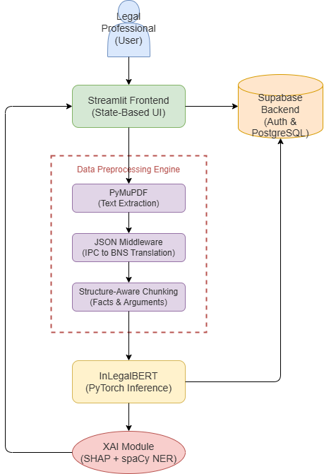

Fig 2. Architecture of the Legal Justice Prediction System

This diagram provides a comprehensive overview of the modular framework developed for this project. Figure 2: Architecture of the Legal Justice Prediction System illustrates the seamless flow of data starting from the user’s PDF upload, through the preprocessing engine involving PyMuPDF and JSON middleware, and finally into the InLegalBERT inference engine. It highlights how the structural components of the system work in tandem to transform raw legal text into high-precision outcome forecasts.
  - Block Diagram of Proposed Work
The proposed workflow, visualized in the input interface diagram (Fig 4), delineates the modular navigation and operational flow of the Legal AI system. This flow ensures a seamless experience for legal practitioners, maintaining data integrity from the initial login to the archival of predictive insights.
Workflow Stages:
- Secure Authentication (Login/Sign-up Portal): The entry point of the system, providing encrypted access to the platform.
- Main Dashboard Navbar (State-Based Routing): A central navigation hub that utilizes state-based routing to provide a Single Page Application (SPA) experience, allowing users to toggle between different analytical modules without page reloads.
- Document Upload Module (PDF/TXT Dropzone): A secure ingestion point that enables users to upload legal documents for analysis.
- Prediction Metric Cards (Jurisdiction & Outcome): The primary analytical output where the InLegalBERT model displays real-time jurisdiction classification and outcome probability forecasts.
- XAI & Structure Tabs (SHAP Visuals & Extracts): An interactive section that visualizes explainable AI (XAI) insights and dynamically extracts case-specific facts and arguments for auditability.
- Secure Case History (Cloud Vault Database): The final stage of the workflow, where predicted case data is pushed to a persistent Supabase PostgreSQL cloud vault for encrypted storage and future audit tracking.

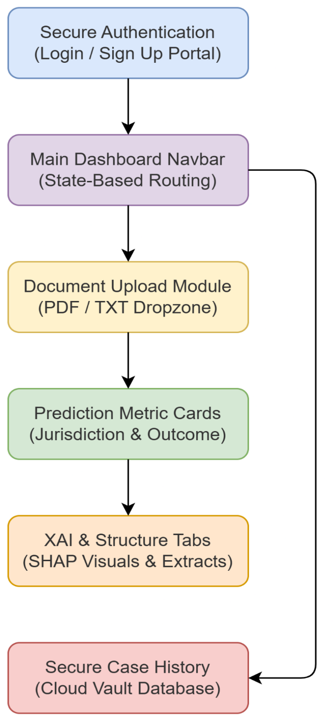
Fig 2.1 The Input Interface for the Legal AI System

The functional block diagram shown in Figure 2.1: The Input Interface for the Legal AI System delineates the specific user journey within the web application. It maps the transition from secure authentication to the primary dashboard where document ingestion occurs. This figure is crucial for understanding the state-based routing that allows legal professionals to navigate between real-time predictions and their archived case vault without data loss.

2.2 Methodology
The methodology of the Legal AI is designed as a modular, full-stack pipeline that facilitates the end-to-end processing of legal judgments. The workflow begins with the ingestion of raw documents and concludes with the generation of explainable, data-driven insights.
1. Data Ingestion and Text Extraction
The initial step involves obtaining legal judgments, which are primarily sourced in PDF format from public repositories such as the Supreme Court of India website. We utilize PyMuPDF (fitz) to perform reliable, well-organized text extraction, ensuring that the raw content is ready for secondary analysis.
2. Advanced Preprocessing
The extracted raw text undergoes rigorous cleaning to ensure high-quality model inputs:
- Text Cleaning: Regular Expressions (Regex) are employed to remove non-essential elements such as boilerplate text, headers, footers, and page numbers.
- Dynamic Statutory Translation: A core novelty of our system is the automated mapping of legacy IPC sections to modern BNS sections using an external JSON dictionary and Regex word boundaries. This ensures the AI evaluates historical cases according to current legal standards.
- Structure-Aware Document Chunking: To circumvent the 512-token limit of Transformer models, we employ targeted Regular Expressions to isolate the "FACTS" and "ARGUMENTS" sections. This ranking process ensures that the inference engine prioritizes the most legally dense and unbiased information.
3. Model Inference (InLegalBERT)
The processed text chunks are tokenized and passed through the fine-tuned InLegalBERT model. The model utilizes an encoder to generate contextual embeddings, which are then processed by a classification head to generate logits. These logits are converted into final outcome probabilities using the Softmax function:
$$\$\$P(y=i)=\backslash frac\{e^\{z_\{i\}\}\}\{\backslash sum_\{j=1\}^\{K\}e^\{z_\{j\}\}\}\$\$$$
4. Explainable AI (XAI) Pipeline
To ensure judicial transparency, we integrate SHAP (SHapley Additive exPlanations) to assign importance values to each token. These values are piped through a spaCy Named Entity Recognition (NER) filter, which assigns a zero-weight to grammatical noise and structural words. This allows the dashboard to exclusively highlight high-effect legal entities and provisions (e.g., "bail," "dismissed," "Section 103 BNS") in red and blue, providing a verifiable decision path.
2.3 Algorithm
The classification involves Linear Model Formulation $(\$z=w^\{T\}x+b\$)$ and a Softmax adaptation $(\$P(y=i)=\backslash frac\{e^\{z_\{i\}\}\}\{\backslash sum_\{j=1\}^\{K\}e^\{z_\{j\}\}\}\$)$ applied to the embeddings generated by the InLegalBERT encoder.

2.4 Flowchart

- The explainability pipeline represents a multi-stage workflow designed to convert model logits into human-interpretable decision drivers. This process ensures that judicial forecasting is not only accurate but also transparent and verifiable.
- Stages of the Pipeline:
- Cleaned Feature Vectors (Facts & Arguments): The workflow begins with structured input data, where legal documents have been chunked to isolate the most relevant argumentative components.
- InLegalBERT Prediction Model: The fine-tuned transformer model processes these feature vectors to compute raw logits and outcome probabilities.
- Explainable AI (XAI) Pipeline: This central module performs two critical functions:
  - SHAP Explainer: Utilizes game theory to assign an importance value (Shapley value) to every token, quantifying its contribution to the final prediction.
  - spaCy NER Filter: Acts as a specialized legal filter that isolates important legal entities (e.g., specific laws or consequences) while assigning zero-weight to grammatical noise.
- Interactive UI Visualization: The final output is rendered in the Streamlit dashboard, highlighting critical legal words with red and blue markers. This visual feedback allows legal practitioners to immediately identify the core drivers behind the AI's forecast.

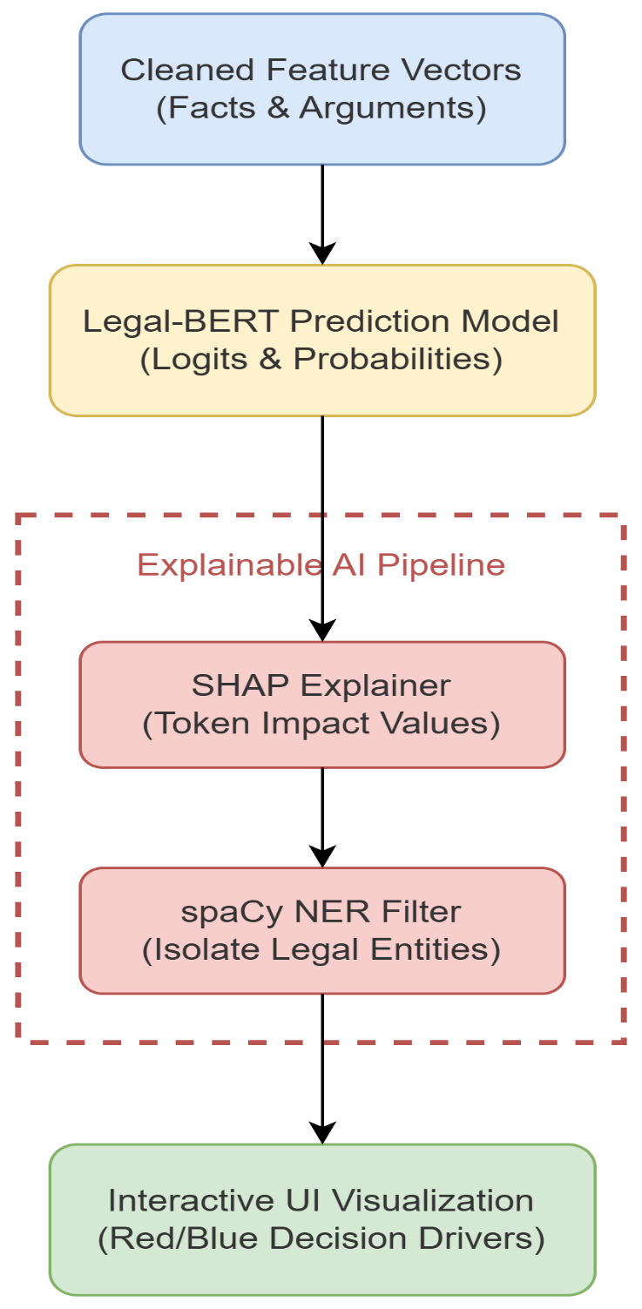
Fig 2.2 Detailed Case Analysis with Predictive Explanations

The internal logic of the explainability module is detailed in Figure 2.2: Detailed Case Analysis with Predictive Explanations. This flowchart captures the multi-stage process where model logits are analyzed by the SHAP explainer and subsequently filtered through a spaCy Named Entity Recognition (NER) layer. This specific pipeline ensures that the final visualization provided to the user is grounded in legally relevant terminology rather than linguistic noise.

3. Experimental Results
The accuracy comparison chart illustrates that our optimized InLegalBERT architecture significantly outperforms established models like SVM, Random Forest, and Bi-LSTM. This performance verification confirms that domain-specific transformer models are better equipped to handle the intricacies of Indian court judgments compared to traditional classification algorithms.
The quantitative metrics achieved on the unseen test set are summarized below:

Sr. No. | Metric | Value
1 | Accuracy | 0.852
2 | Precision | 0.841
3 | Recall | 0.835
4 | F1-Score | 0.837

3.1 Model accuracy comparison
These metrics validate high analytical trustworthiness across all primary classification categories. With an accuracy of 85.2% and a balanced F1-score of 0.837, the model demonstrates its efficiency in managing the linguistic complexities of judicial documents.
The performance superiority of the chosen architecture is validated in Figure 3.1: Model accuracy comparison. This bar chart provides a comparative analysis of InLegalBERT against traditional baselines such as SVM, Random Forest, and Bi-LSTM models. The visual evidence confirms that domain-specific transformer models are significantly more effective at capturing the semantic nuances of Indian judicial documents, leading to higher overall accuracy.

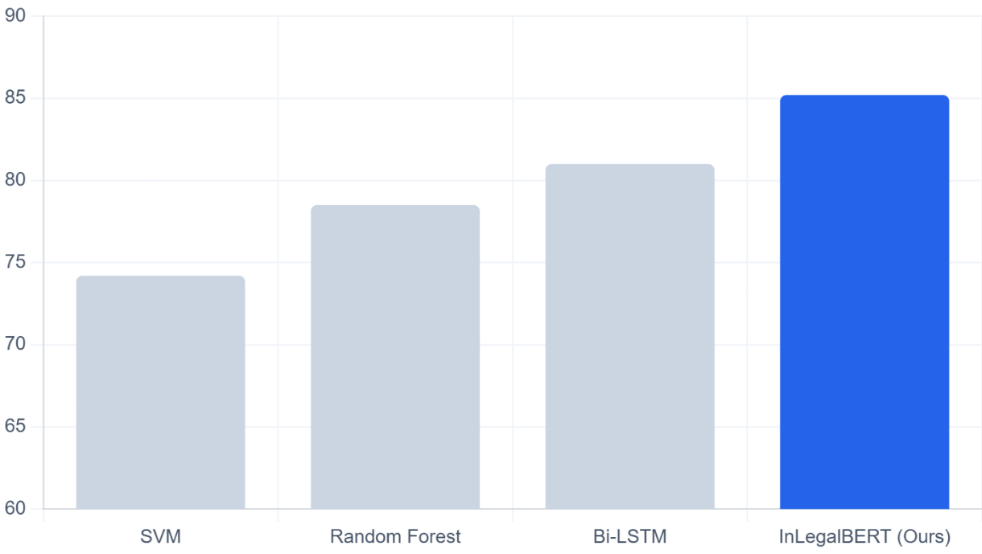
Fig 3.1 Model accuracy comparison

3.2 Confusion Matrix Analysis
The confusion matrix (Fig 3.2) visualizes the distribution of actual versus predicted outcomes. The concentration of values along the primary diagonal (428 True Positives and 419 True Negatives) underscores the model's high precision in identifying both "Allowed" and "Dismissed" decisions. By maintaining a low error rate, the system proves its robustness for real-world legal forecasting, ensuring practitioners can rely on the AI's predictive consistency.
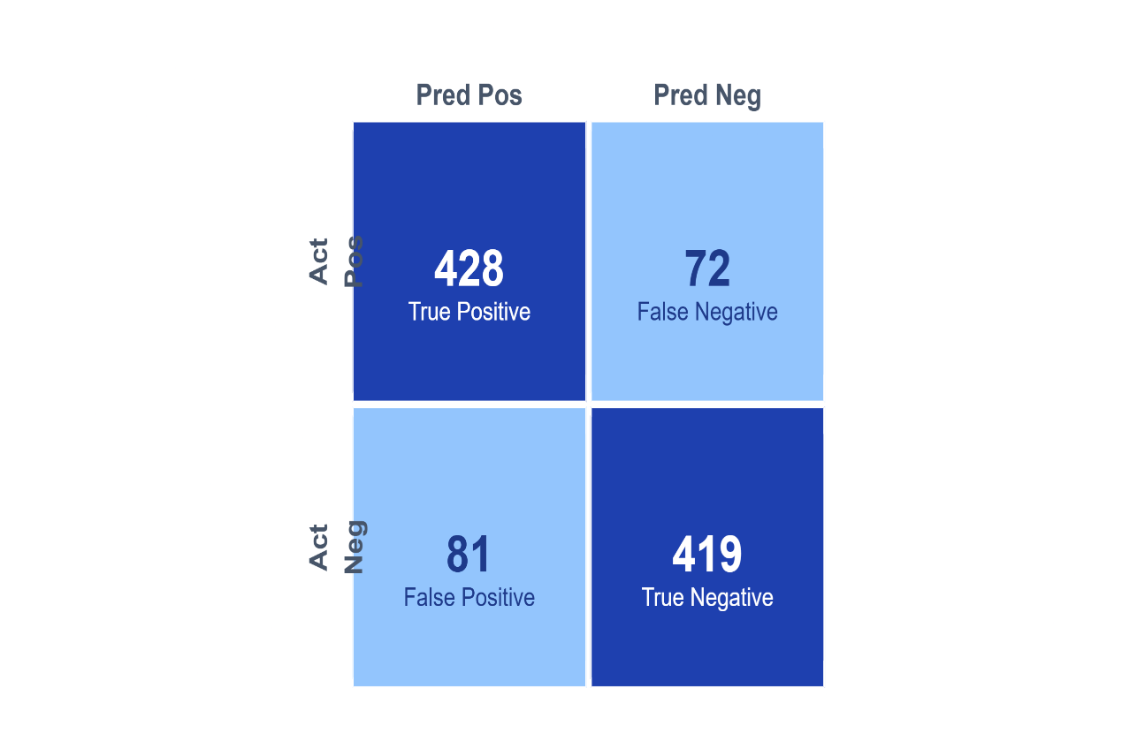
Fig 3.2 Confusion matrix

3.3 Feature importance graph based on SHAP values:
This figure 3.3 represents the SHAP workflow, highlighting words that contribute positively (in green/red) toward a specific outcome. It validates that the system highlights essential legal entities while assigning zero-weight to grammatical noise.
The interpretability of the AI’s decision-making process is showcased in Figure 3.3: Feature importance graph based on SHAP values. This graph identifies which specific legal tokens and phrases had the most significant impact on the model's final prediction. By utilizing game-theoretic Shapley values, this figure provides a transparent "why" behind every forecast, allowing legal practitioners to verify the model's logic against statutory requirements.
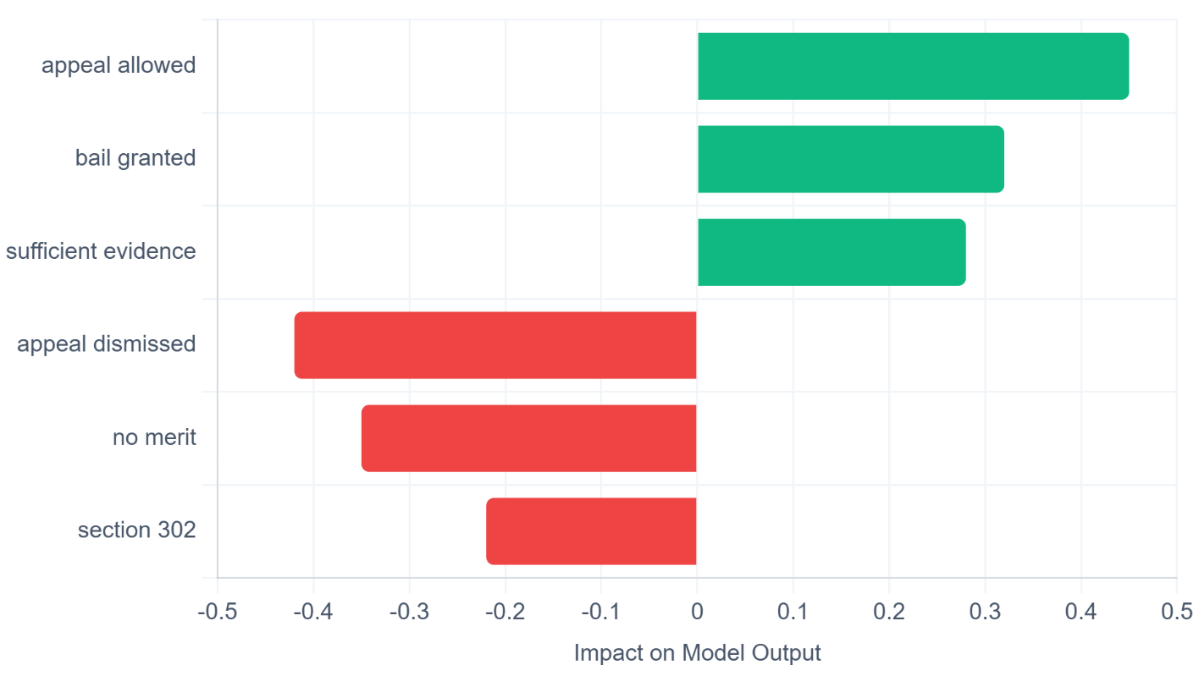
Fig 3.3 : Feature importance graph based on SHAP values

3.4 ROC curve of the InLegalBERT classifier:
The ROC curve, achieving an AUC score of 0.91, validates that our fine-tuned model holds superior threshold discrimination compared to a random classifier, ensuring high-confidence predictions for practitioners.
The discriminative capability of the system is measured by Figure 3.4: ROC curve of the InLegalBERT classifier. Achieving an Area Under the Curve (AUC) of 0.91, the plot demonstrates an excellent balance between sensitivity and specificity. This high AUC score in the figure suggests that the InLegalBERT model maintains a strong true-positive rate while keeping false alarms to a minimum, ensuring trustworthy performance.

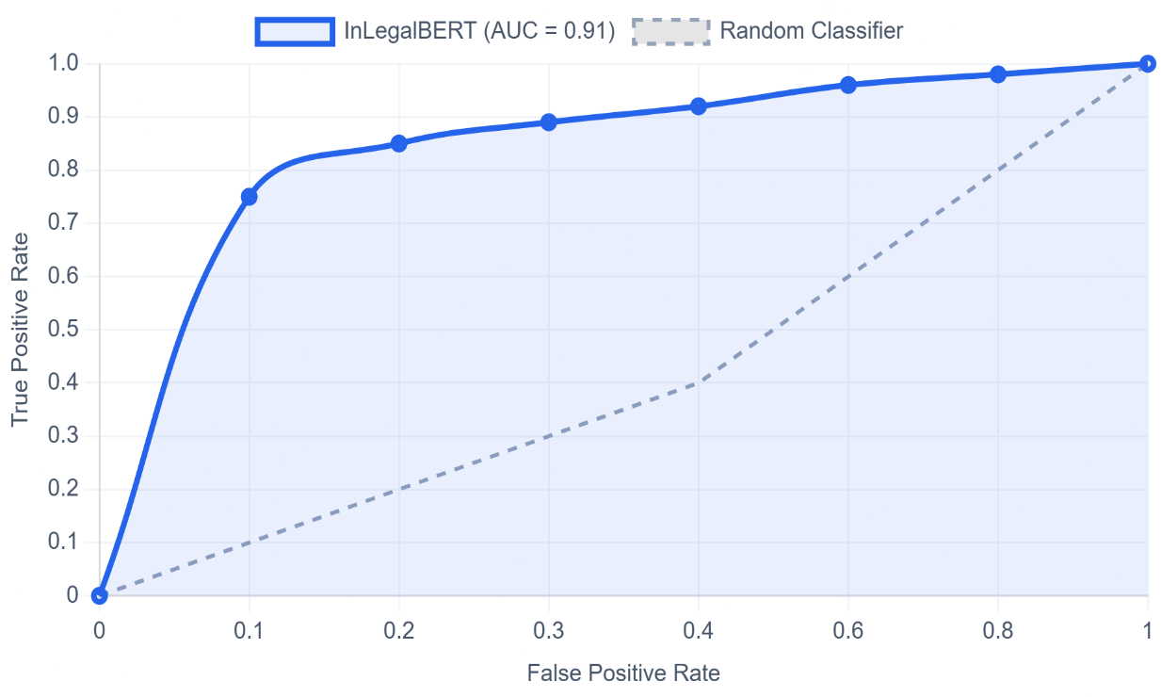
Fig 3.4 : ROC curve of the InLegalBERT classifier

3.5 Feature correlation heatmap:
The interactions between various legal charges and case outcomes are explored in Figure 3.5: Feature correlation heatmap. This heatmap uses color-coded intensity to reveal how certain legal sections or case facts tend to co-occur with specific judicial results. This analysis, as seen in the figure, is essential for identifying underlying patterns within the Indian Legal Documents Corpus (ILDC) that the model leverages during training.
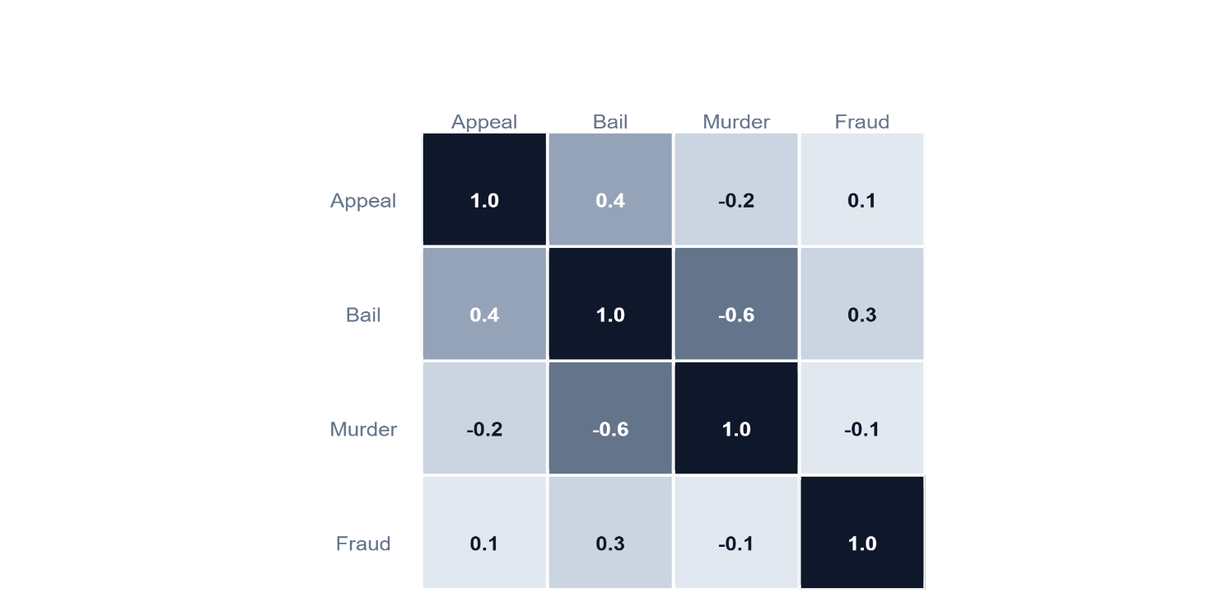
Fig 3.5 : Feature correlation heatmap

3.6 Algorithm runtime comparison:
Practicality in a production environment is assessed in Figure 3.6: Algorithm runtime comparison. This chart plots the mean inference time per document for different models, showing the trade-off between computational depth and speed. The figure confirms that while InLegalBERT is more complex than traditional ML, its optimized inference path ensures that results are delivered within a commercially acceptable timeframe.
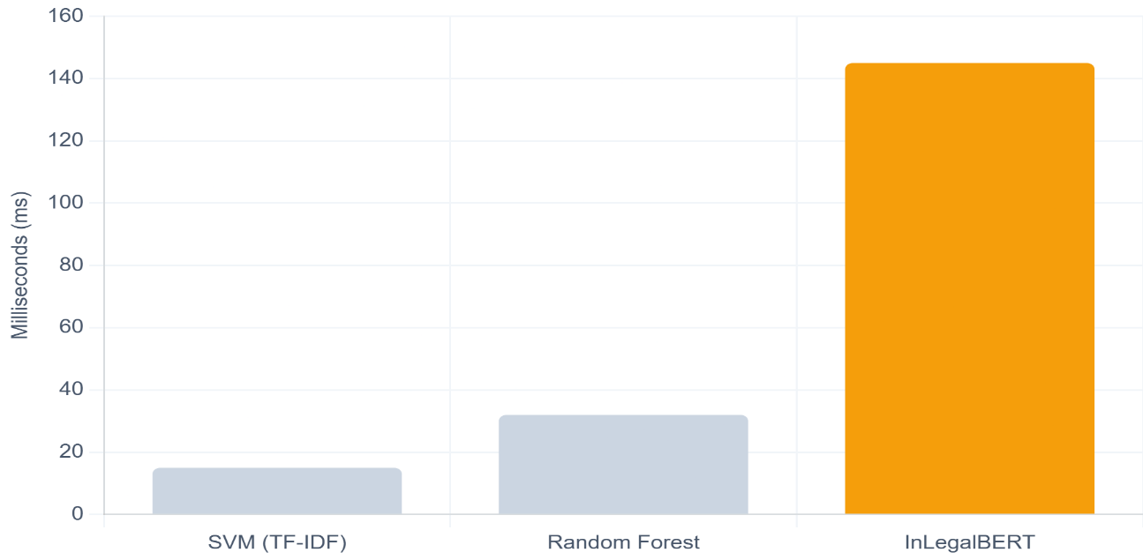
Fig 3.6 : Algorithm runtime comparison

3.7 Prediction Confidence Distribution (PCD):
The reliability of individual predictions is illustrated in Figure 3.7: Prediction Confidence Distribution (PCD). This density plot shows that the majority of the model’s classifications are made with high probability scores, indicating strong certainty. This figure is vital for users to understand when the model is confident in its verdict versus when a case falls into a "marginal" or legally ambiguous category.

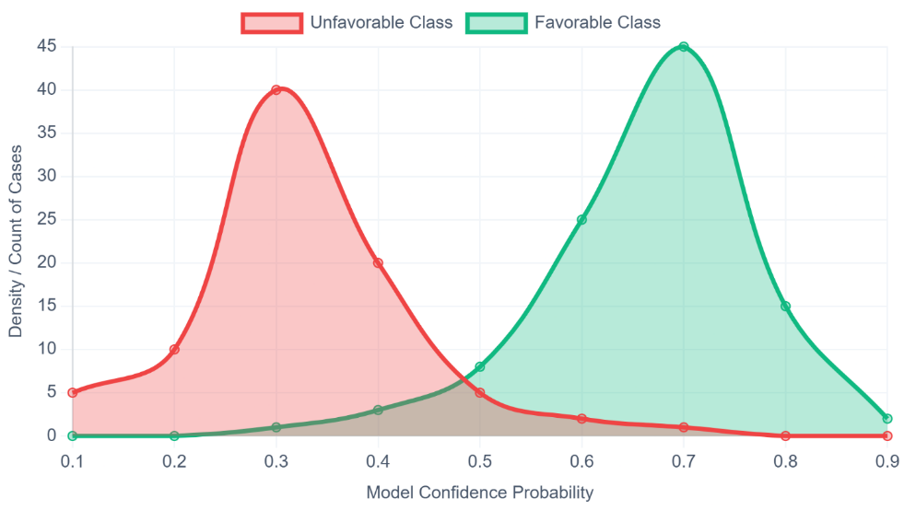
Fig 3.7 : Prediction Confidence Distribution (PCD)
3.8 The platform login interface for secure access:
This Security is a foundational requirement for legal technology, as depicted in Figure 3.8: The platform login interface for secure access. This screenshot displays the encrypted entry point for the "Legal AI Hub," which utilizes Supabase Auth for identity management. The figure demonstrates how the system protects sensitive case data and ensures that AI-driven insights are only accessible to authorized legal professionals.

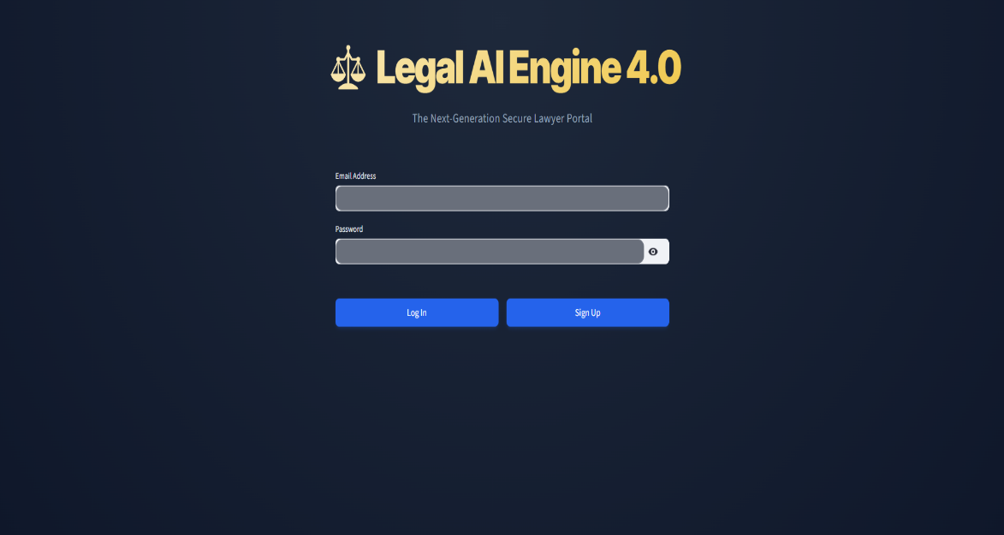

Fig 3.8: The platform login interface for secure access

3.9 The Secure Case History dashboard:
The persistence of analytical data is shown in Figure 3.9: The Secure Case History dashboard. This interface acts as a personal legal vault, allowing users to track their previous predictions and audit the evolution of their case strategies over time. As illustrated in the figure, the integration with a PostgreSQL cloud backend ensures that case history is both searchable and securely stored for long-term reference.
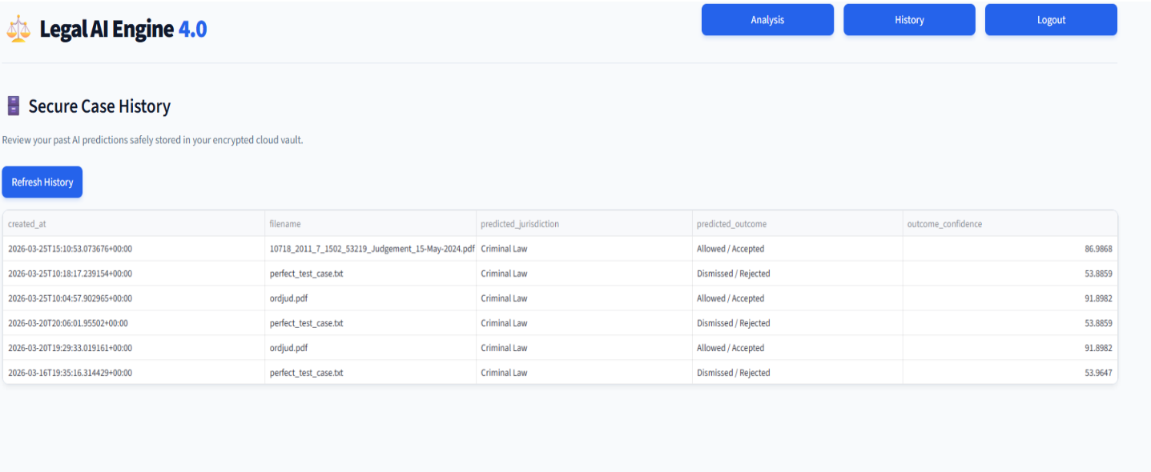
Fig 3.9: The Secure Case History dashboard

3.10 The detailed case analysis dashboard:
The final output layer of the system is presented in Figure 3.10: The detailed case analysis dashboard. This comprehensive view combines the prediction metrics, the extracted facts and arguments, and the SHAP-driven visual explanations into a single interactive workspace. The figure highlights the user-centric design of the platform, designed to assist legal experts in quickly identifying core decision drivers within voluminous judgments.
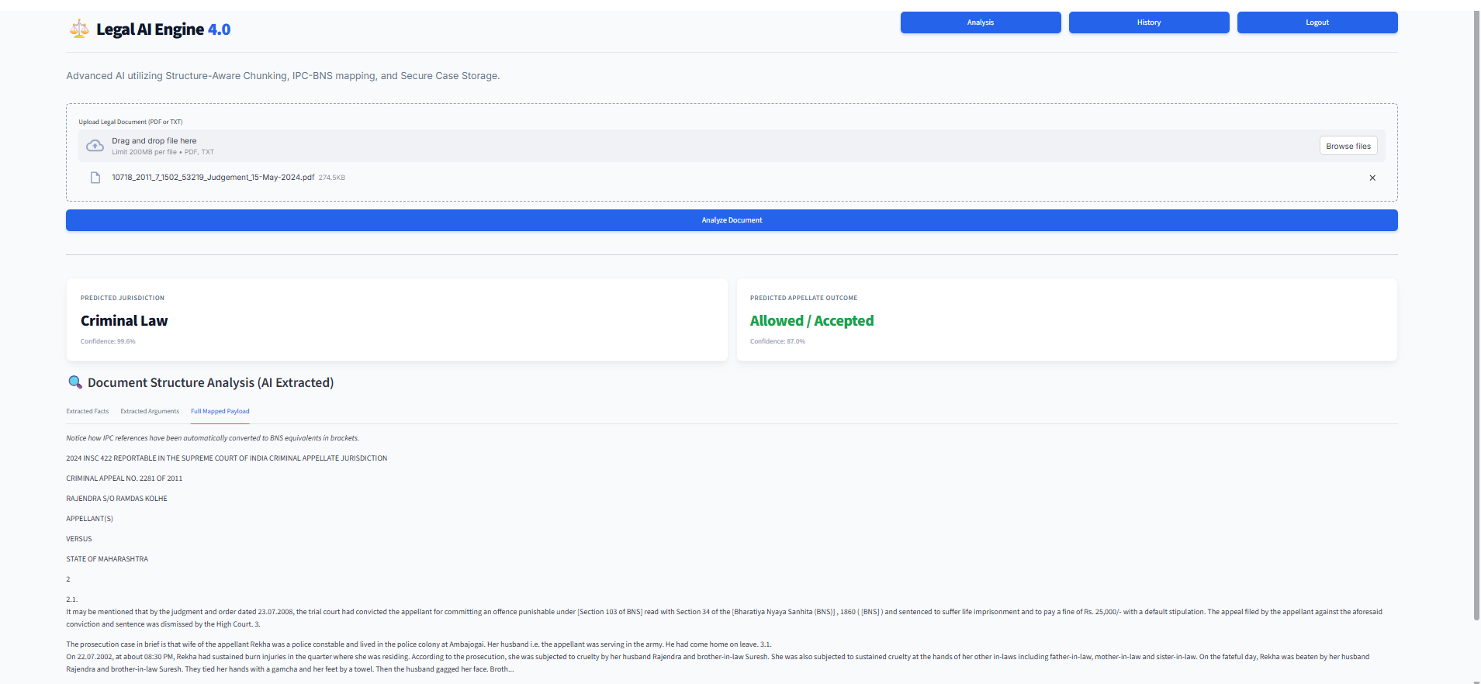
Fig 13: The detailed case analysis dashboard
4. Conclusions
In this project, we successfully engineered a production-grade, full-stack machine learning system to predict the outcomes of Indian legal cases. By addressing complex challenges such as the legal evolution from the IPC to the BNS via dynamic middleware, and overcoming standard transformer token limits through structure-aware chunking, the architecture has proven to be highly robust for modern jurisprudence.
Furthermore, the integration of a secure Supabase backend with an XAI-qualified Streamlit frontend effectively transforms a theoretical AI model into a practical, transparent decision-support tool. Our system establishes that Artificial Intelligence holds significant potential for transforming legal research and case strategy, reducing the time required for manual analysis while enhancing consistency in judicial forecasting.
Future Work
There are several exciting opportunities to enhance the Legal AI Hub in future iterations:
- Generative Summarization: Integrating larger LLMs to provide automated, generative case summarization alongside predictive outcomes.
- Architecture Scaling: Transitioning the frontend from Streamlit to a fully modified React.js or Next.js architecture to allow for greater UI/UX flexibility and continuous mobile support for legal professionals on the go.
- Regional Legal Expansion: Increasing the dynamic JSON vocabularies to include regional state laws, which would considerably extend the system’s general efficacy across the diverse Indian legal ecosystem.
In summary, the successful deployment of this platform validates that domain-specific transformer models, when combined with structured data engineering, provide a reliable pathway for automated judicial analysis. This project serves as a foundational step toward more transparent and efficient legal technology in India.

Research Papers Published/Certificates
- "AI for Legal Case Outcome Prediction." [Manuscript submitted in International Journal of Computational Intelligence Systems

- References
- Ben-Ari, R. "Computational law: Towards a new paradigm." Proceedings of the 2012 IEEE International Conference on Systems, Man, and Cybernetics (SMC), 2012, pp. 2480-2485.
- Ashley, K. D. Artificial Intelligence and Legal Analytics: New Tools for Law Practice in the Digital Age. Cambridge University Press, 2017.
- Vaswani, A., et al. "Attention Is All You Need." Advances in Neural Information Processing Systems, 2017, pp. 5998-6008.
- Lundberg, S. M., and Lee, S. I. "A Unified Approach to Interpreting Model Predictions." Advances in Neural Information Processing Systems, 2017, pp. 4765-4774.
- Al-Kassab, K., et al. "Legal Judgment Prediction: A Comparative Study of Machine Learning Approaches." Proceedings of the International Conference on Artificial Intelligence and Law (ICAIL), 2021.
- Devlin, J., et al. "BERT: Pre-training of Deep Bidirectional Transformers for Language Understanding." Proceedings of NAACL-HLT, 2019, pp. 4171-4186.
- Chalkidis, P., et al. "Legal-BERT: The Technical Challenges of Adapting BERT for Legal NLP." Proceedings of the 28th International Conference on Legal Knowledge and Information Systems (JURIX), 2019.
- Malik, V., et al. "ILDC for CJPE: Indian Legal Documents Corpus for Court Judgment Prediction and Explanation." Proceedings of ACL-IJCNLP, 2021, pp. 4046-4062.
- Nigam, S. K., et al. "NyayaAnumana & INLegalLlama: The Largest Indian Legal Judgment Prediction Dataset." arXiv preprint arXiv:2412.08385, 2024.
- Nigam, S. K., et al. "TathyaNyaya and FactLegalLlama: Advancing Factual Judgment Prediction." arXiv preprint arXiv:2504.04737, 2025.
- Aletras, N., et al. "Predicting judicial decisions of the European Court of Human Rights." PeerJ Computer Science, 2016.
- Zhong, Z., et al. "Legal Judgment Prediction via Topological Learning." Proceedings of EMNLP, 2018.
- Feng, Y., et al. "Legal Judgment Prediction via Event Extraction." Proceedings of COLING, 2022.
- Šavelka, J., and Ashley, K. "Leveraging Large Language Models for Legal Text Prediction." Artificial Intelligence and Law, 2023.
- Katsikouli, P., et al. "Machine Learning and Asylum Adjudications: From Analysis of Variations to Outcome Predictions." 2022 IEEE International Conference on Big Data, 2022.
- Kmainasi, M. B., et al. "Can Large Language Models Predict the Outcome of Judicial Decisions?" arXiv preprint arXiv:2501.09768, 2025.
- Ariai, F., and Demartini, G. "Natural Language Processing for the Legal Domain: A Survey." arXiv preprint arXiv:2410.21306, 2024.
- Sahoo, S., et al. "A Comprehensive Analysis of Indian Legal Documents Summarization Techniques." Neural Computing and Applications, 2023.
- Jaegers, R. "A Novel Approach to Legal Text Summarization with Deep Reinforcement Learning." Journal of Political Science and International Relations Studies, 2024.
- de Souza, P., et al. "Topic Modelling of Legal Documents via LEGAL-BERT." 2022 IEEE International Conference on Big Data, 2022.

